ADDITIONAL PROPERTY TRANSFER TAX
The Ministry of Finance has introduced a new Additional Property Transfer Tax effective August 2nd, 2016. This additional tax is payable in addition to the general property tax. Along with the tax that is payable, there is also a new Additional Property Transfer Tax Return form that must be completed. Please read the Ministry of Finance Tax Information Sheet 2016-006 for full details.
The LTSA in conjunction with the Ministry of Finance have announced that a new Property Transfer Tax (PTT) Form Version 27 will be released on August 2nd, 2016. This updated form is due to the introduction of the additional tax. For important information regarding this form, please read the LTSA announcement.
When a transaction requires the collection and remittance of the additional property transfer tax the calculation of this tax must be done manually. There are two ways to enter the additional property transfer tax in ProSuite - choose the one that works best for your firm.
PURCHASE FILE WORKFLOW
- Add all Buyers to the Parties screen.
- Complete the Property>Legal and Land Value tabs with the required information to allow the regular PTT to calculate.
- Complete the Additional Property Transfer Tax Return.
This is a manual form prepared by the Ministry of Finance and can be obtained here. For convenience, this form can also be obtained from the ProSuite>Generate Documents screen (L-065 Additional Property Transfer Tax Return – Blank) however it will not be populated due to the nature of the form. Follow the instructions provided in the Tax Information Sheet 2016-006 to complete and submit the form.
Note 1: Unlike the regular Property Transfer Tax Return, this form does not automatically calculate the tax amounts. These must be calculated manually.
Note 2: There are no schedules provided for additional buyers, sellers or properties. There is a checkbox at the top of the form If you require more space and have attached pages, check here. Free form schedules are to be added as needed.
- Once the additional property transfer tax payable is determined in step 3 it can be added to the Net PTT  - On the Land Value tab edit the Net PTT field to reflect the total of the Net PTT plus the Additional PTT  - The field will be highlighted green to indicate that the value was manually overridden  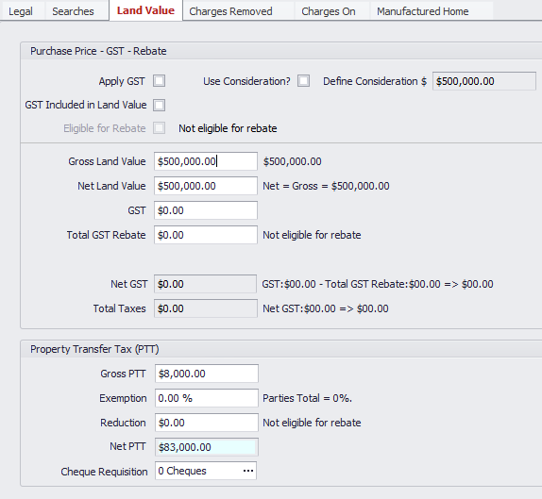  - One entry will appear on the Buyer’s Statement of Adjustments and In/Out Trust Rec for PTT | - Once the additional property transfer tax payable is determined in step 3 it can be entered on the Buyer’s SOA as follows  - On the Buyer’s Other Adjustments tab add a new Standard Adjustment  - Enter the total additional property transfer tax payable in the Adjustment field  - Ensure Applied To = Buyer (In/Out) and As = Debit from Buyer  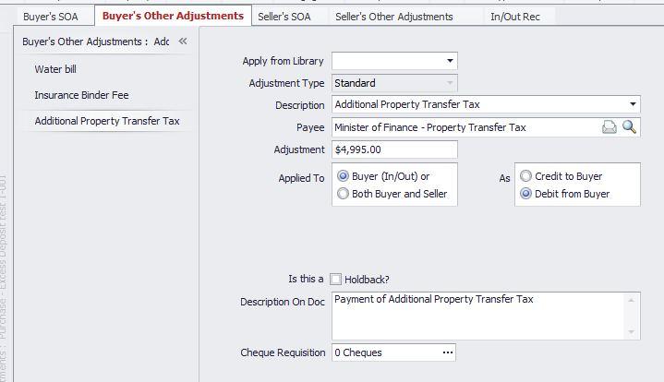  - Two entries will appear on the Buyer’s Statement of Adjustments and In/Out Trust Rec for PTT
- Generate the Property Transfer Tax Return V27 ensuring that all required fields are completed.
- Complete the Additional Tax Payable field in Section I 6 b with the total amount of the additional property transfer tax and tab off the field. The form will automatically recalculate the total Property Transfer Tax payable.
